**Connection draining:**

* If a connection happens to one EC2 instance and that goes down after that. The connection will be waiting for some duration time. By default, it is 300 seconds.

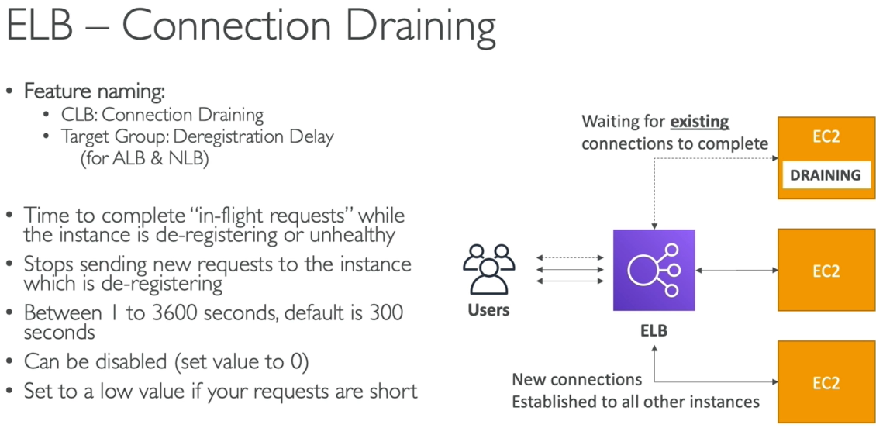

* And the connection draining means, for example, we have an instance which is slow and not responding properly. Then ELB finds it as unhealthy and needs to remove the server from load balancer but we need to give some time to the server for finish its ongoing connections. By default, it is 300 seconds. Once the servers enter connection draining, it won’t accept any new connections

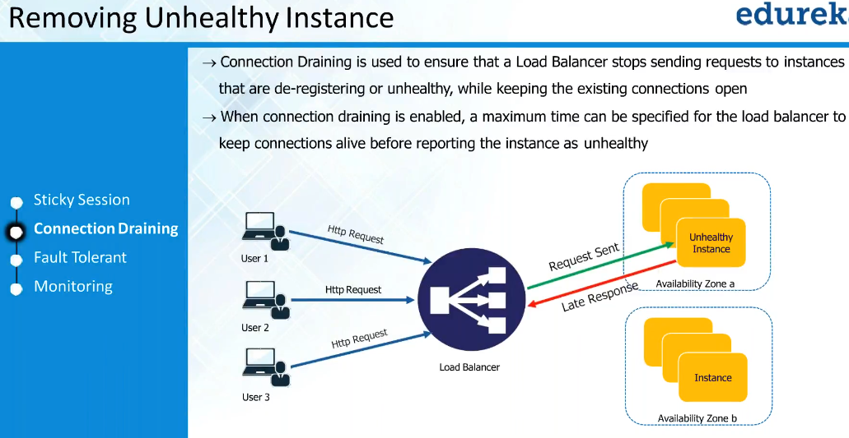

* Connection drain is used when we want to remove the unhealthy instance
* Suppose, we want to do some activity on the server, then we need to not allow any request to the server, then we need to enable the connection draining on the server
* Once activity done, we can bring it back to cluster